# CHAPTER FOUR

# SYSTEM IMPLEMENTATION AND EVALUATION

# 4.1 PREAMBLE

This section describes how the new system is implemented for effective operation. It shows a concise detail of the process of implementation and sample of the working (new) system designed.

# SYSTEM TESTING AND EVALUATION

Testing is conducted as an important part of a system development life-cycle. Because, after testing is carried on the new system, we can ensure that the new system meets its required functionalities and is error-free

**Unit Testing**

In this place, individual units or single components of the system are tested independently to ensure that individual phases are working effectively without errors.

**Integration Testing**

Testing of the program was implemented using integration testing all the units were put together as one so they function as one. The link between the various units were tested to be sure that they are correctly integrated, also to be sure that the units can function correctly together as one.

# 4.3 SYSTEM CONVERSION PLAN

The conversion of the new system is parallel approach i.e. both the existing and new system will be used concurrently before it finally has good stand in the system. This is used because having jumped out to new system directly with existing system completely out can cause breakdown to every record already taken during the cause of using the new system alone if there is any problem in the program maintenance.

# 4.4 SYSTEM INSTALLATION

In order to use the proposed application on any computer system, the following steps need to be taken:

1. Boot the system.
2. Make sure, pip, pipenv and Python 3 and greater is installed.
3. Copy your project folder to any location of your choice.
4. Open project folder in Visual Studio Code
5. On the terminal run “pipenv install requirements.txt”
6. On the terminal run “python manage.py runserver”
7. Open any browser on the system example Chrome, Microsoft Edge, Mozilla Firefox.
8. On the address bar, type <http://127.0.0.1> and press the enter key.

# 4.5 SECURITY MEASURES

Since the scope of the website is public, some of the information such as index page, about us, materials e.t.c are available to anyone who visits the website. But some other information and functionalities are restricted to some and not all who visit the website. The restrictions are carried out by the use of passwords which gives different level of access to users. The highest level of access is held by the admin, followed by the staff and then the student with lesser access.

# 4.6 Sample Outputs

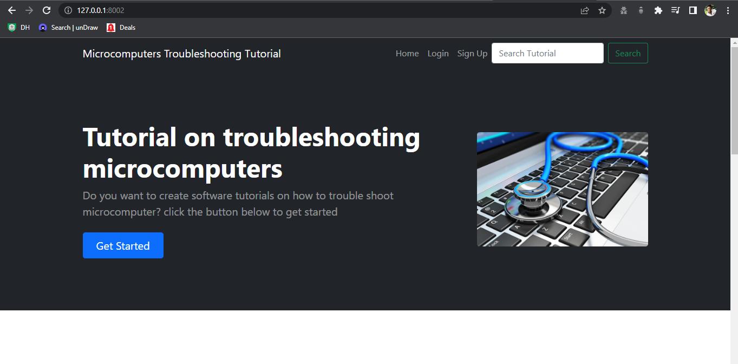

**Fig 4.1 Home Page**

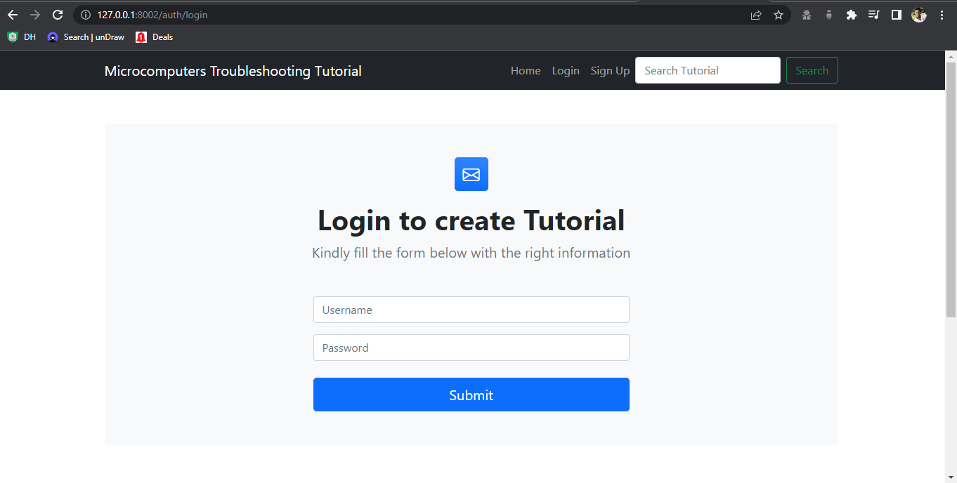

**Fig 4.2 Login Form**

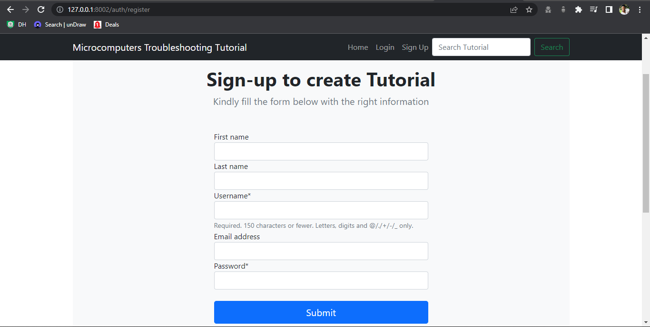

**Fig 4.3 Sign up Tutorial Form**

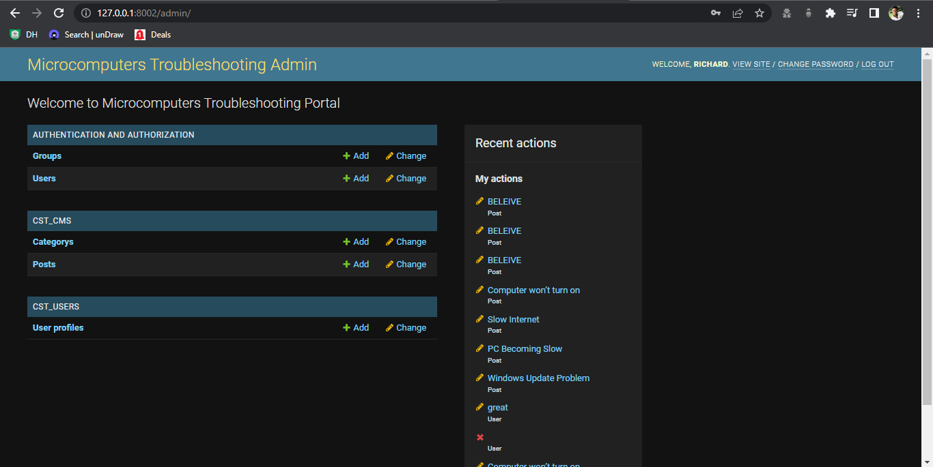

**Fig 4.4 Admin Dashboard**

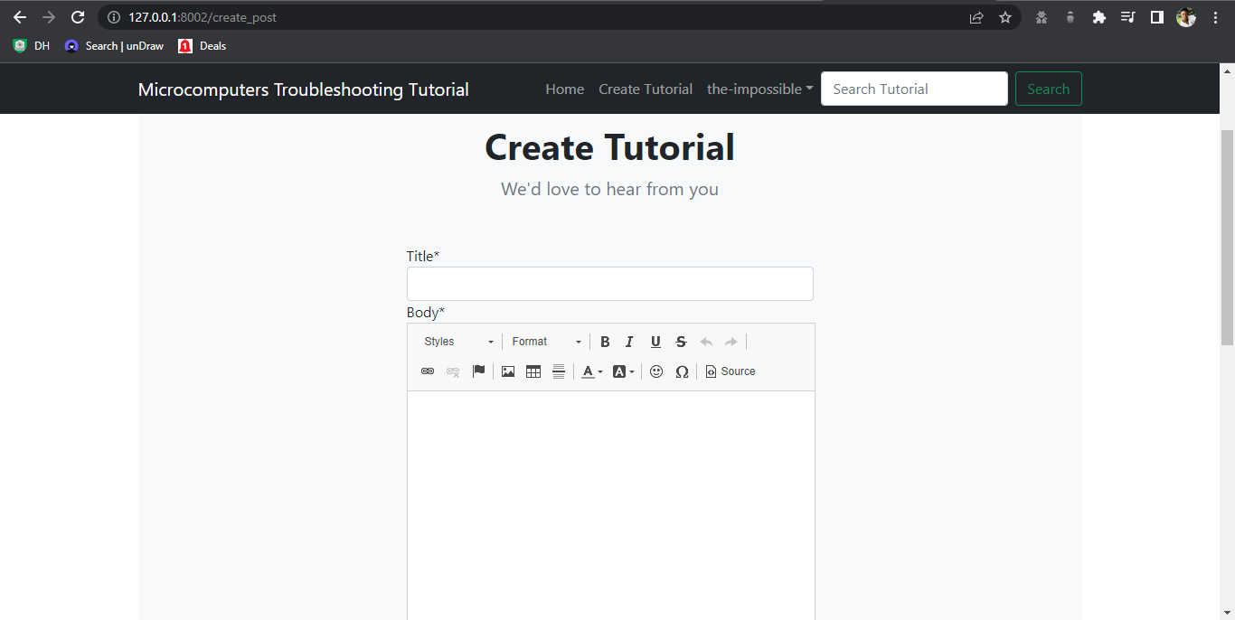

**Fig 4.5 Create Tutorial**

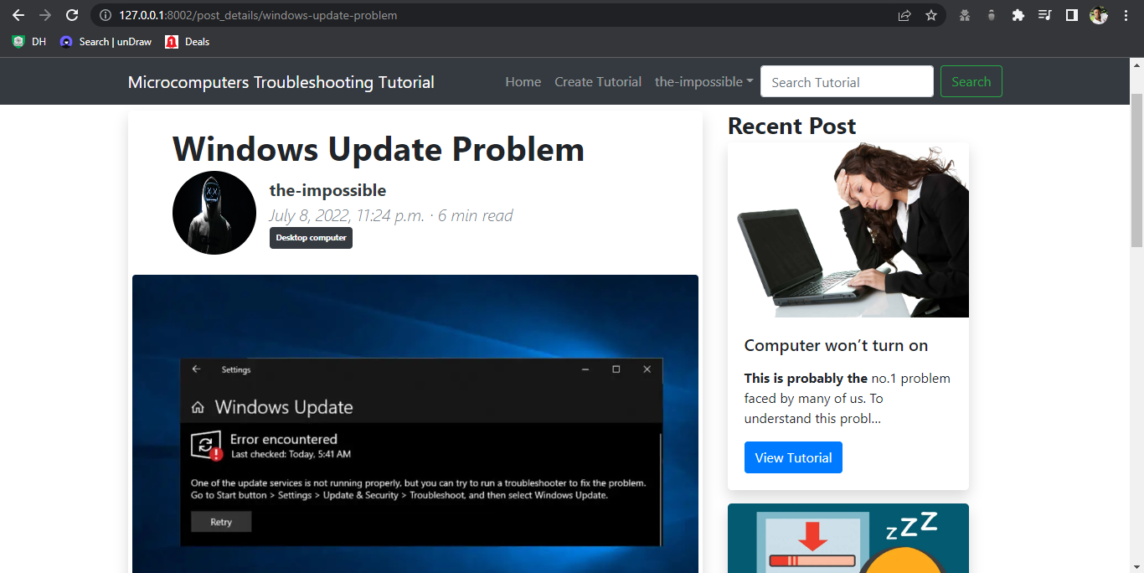

**Fig 4.5 Tutorial Details**

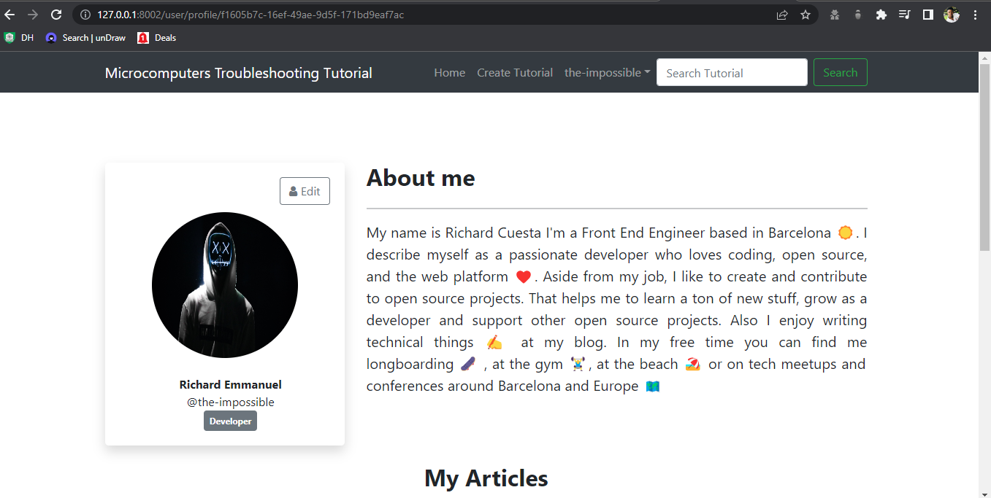

**Fig 4.6 User Profile Page**

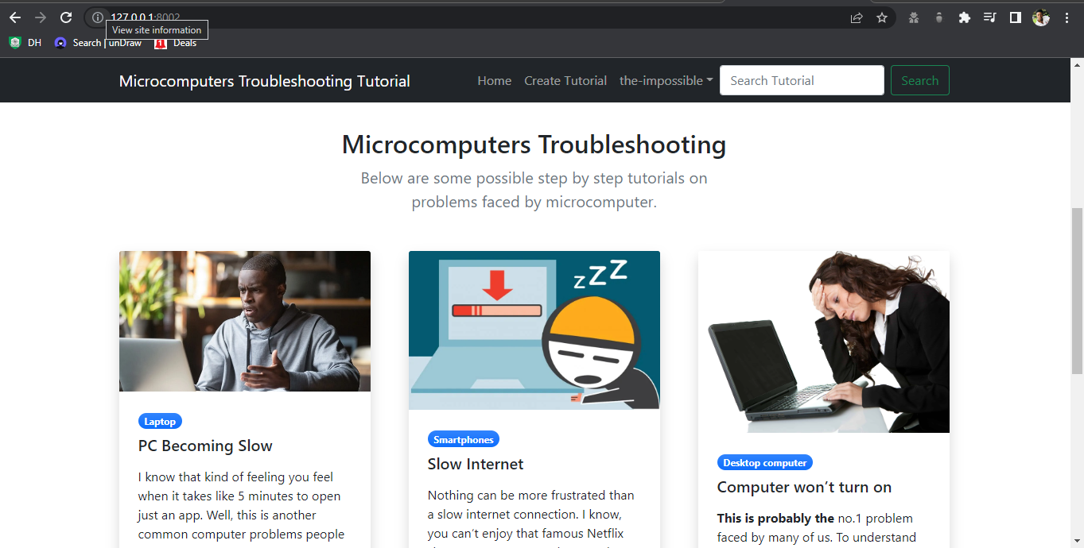

**Fig 4.7 Microcomputer Troubleshooting Tutorials**

# CHAPTER FIVE

# Summary Conclusion and Recommendation

# 5.1 Summary

This project is titled “Computerized Software Tutorial on Troubleshooting Micro-Computer” aimed to efficiently provide authentic solution or troubleshooting process on problem regarding to micro-computer, reduce the cost of parsing information and establish a non-location-based platform for technical users and general users to find and upload troubleshooting tutorial. This work examines the challenges of the existing system and provides suitable solutions.

# 5.2 Conclusion

There have been many advances on communication and dissemination of information, the introduction of technology particularly in web which appears to be leaving a lasting impression on how the adoption of this technology would help in the growth of the society. It is clear that people are using the internet with increasing frequency, many with the goal of seeking information on tutorials regarding to troubleshooting microcomputers.

# 5.2 Recommendation

This project work is recommended to be adopted by users in search of troubleshooting process for micro-computer, the system user should be competent personnel in skill to approve troubleshooting process suggested by technical user and provide a professional support and monitoring services in micro-computers. Adding an interactive forum/chat platform for interactive troubleshooting process is also recommended.